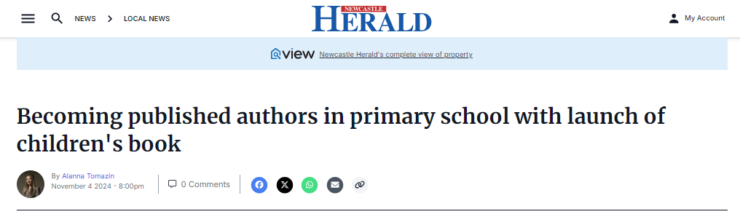
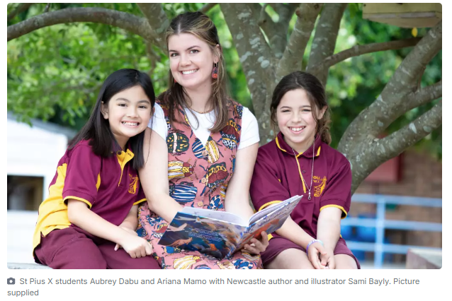
SHARING in the magic of reading, Newcastle author and illustrator Sami Bayly has been hosting school-based workshops, which helped students publish their very own book.
St Pius X Primary School students launched their story Torn Apart on Monday, November 4 which follows the journey of a red kangaroo who starts to wreak havoc on Awabakal country.
"It starts to make the lives for a lot of the beautiful animals nearby quite intense and unpleasant. The story shows how animals can come together and bring peace back to their homes," Ms Bayly said.
The 28-year-old spent a full week with the Windale pupils to create the content before sending it off to the design team. Two hundred copies have been printed and shared across the school community.
"It's so great to see the joy on the kids faces and how excited they are to bring their ideas to life. They can claim they're an author and illustrator from early primary school," she said.
Ms Bayly said the children had a great knowledge and understanding of Indigenous heritage.
"It was a really special opportunity to explore the Indigenous community and it's been a really nice twist," she said.
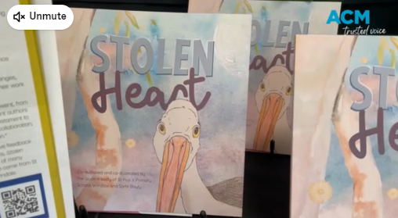
This is the second time Ms Bayly has created a book with St Pius students and has been running workshops at Rutherford and plans to launch a book with students in Gloucester.
"There's been not many days that I haven't been at a school workshop. We have been celebrating some of the strange animals from my books," she said.
She teaches students how to draw and expresses the value of reading and writing to them. She has also taught them about the bookmaking process in hopes one day they choose to follow in her footsteps.
"Reading is super important, it brings important skills like comprehension but it brings you joy," she said.
"I think it's really special for kids whether they're going through a tough time, they can read a book and they can escape. It encourages imagination and encourages so much education and knowledge of the world around you."
