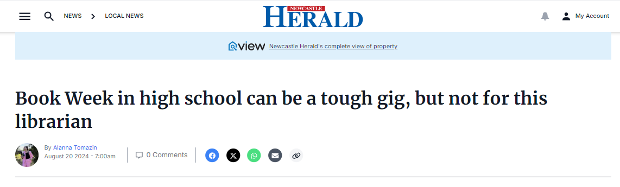
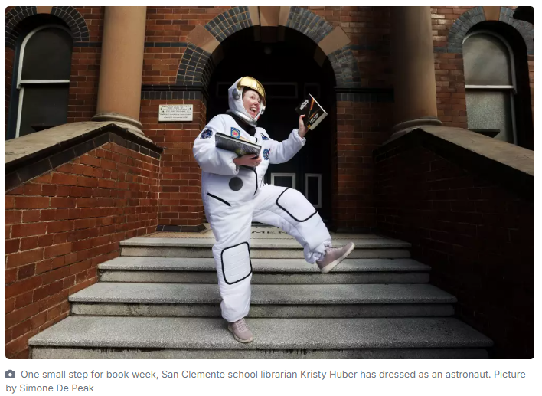
Book Week in high school is a tough gig. There's no parades, no fun dress ups and the magic of reading seems to disappear - but not at Mayfield's San Clemente High School.
In the week leading up to Book Week, librarian Kristy Huber has been a pirate, a magician, a farmer and even the Japanese comic character, Totoro.
On Monday, August 19 she was dressed as an astronaut and plans to be a cowboy, butterfly, a chef and an alien throughout Book Week.
"I'm trying to cover a range of non-fiction and fiction characters to gauge student interest. I've even been a stereotypical cranky librarian with grey hair and oversized glasses," she said.
Coinciding with this year's theme Reading is Magic, Ms Huber has made it her mission to keep reading at the forefront of the student's minds.
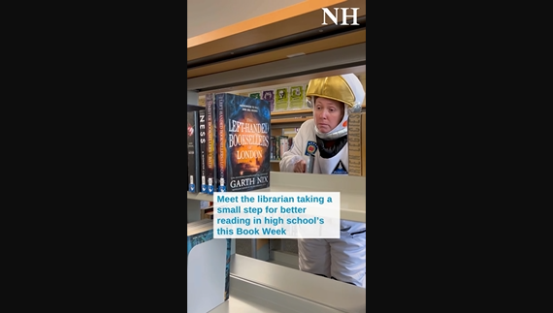
"This year's theme, people take it literally - thinking of all those fantasy themes, but I think reading is magic because of what it can do for your life," she said.
"If you can read it makes everything so much easier for you - academic achievement, critical thinking analysis and personal and social development."
She said reading can also feed into teenagers developing their indentity.
"I think by me dressing up, if I can make kids talk or get them interested or any little hook to become a reader. I'll take it," she said.
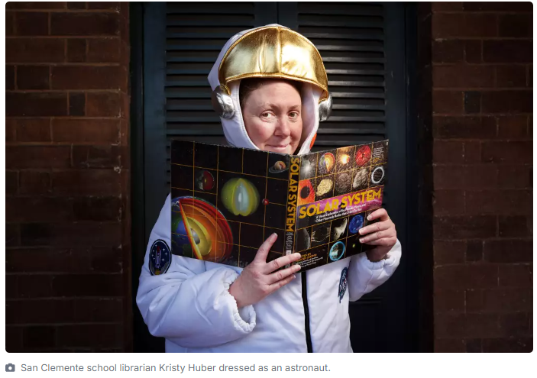
Ms Huber started doing dress ups for Book Week in 2023 and has carried on with the tradition this year as well as decorating the library, having a staff dress up day and activities for students.
"I've been trying to build up our book week profile and some students have asked when they can dress up. If I can swing it one year... I'm hoping to," she said.
Newcastle Transport also shared in the magic of Book Week with one of their bus driver's dressing up as The Magic School Bus driver.
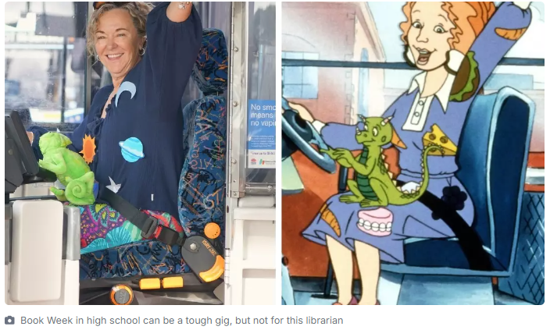
Keolis Downer manager and bus driver, Kathleen Lynch, dressed up as Mrs Frizzle from the beloved 90's book.
"Book Week is definitely a highlight for the team here at Newcastle Transport. It's always fun to see the characters and books the kids are loving each year on board our school buses," she said.
